MACH4METAL

Metalworking machinery
Transito 21,
6909 DA BABBERICH
Netherlands
Tel. +31 (0)316 – 247123
Fax. +31 (0)316 - 247956
info@mach4metal.com
www.mach4metal.com

Account No: 66.52.13.883
IBAN : NL33 INGB 0665 2138 83
BIC : INGBNL2A

DECKEL MAHO DMU 60 T
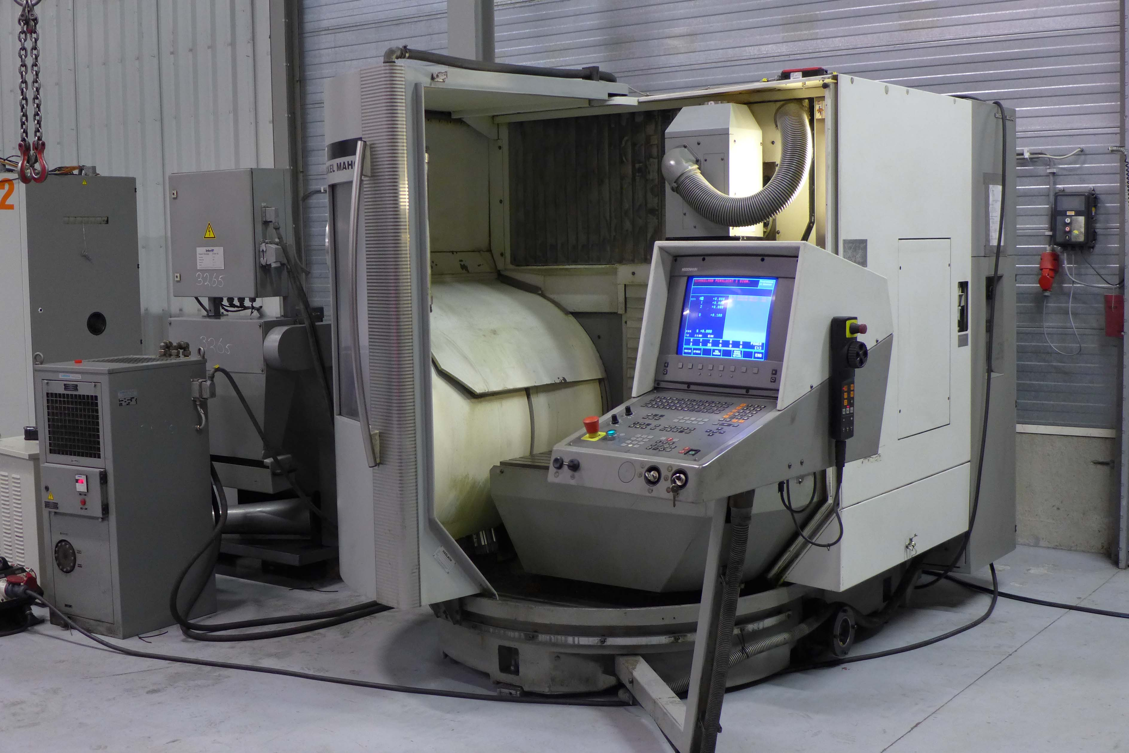
- Make : DECKEL - MAHO
- Type : DMU 60 T
- Age : 2001 / 6200 H
- No. : 1103 552 4594

- Capacity working range
- X : 630
- Y : 560
- Z : 560
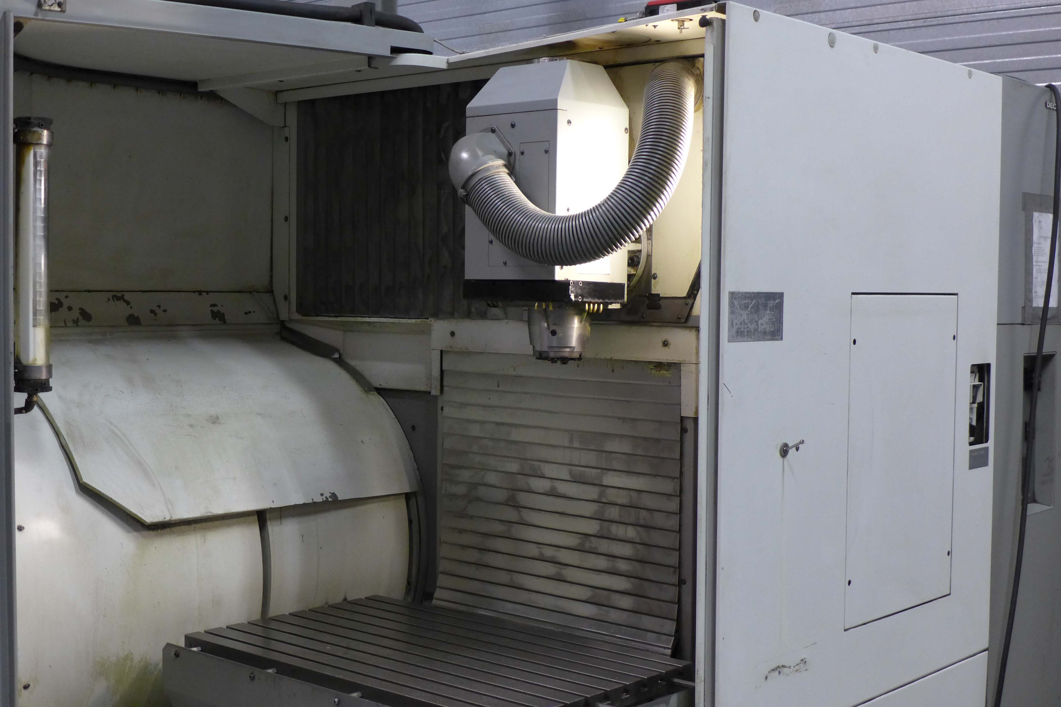
- Table length : 1.000
- Table width : 600
- Table load : 500

- Spindle : Sk 40 / HSK 63
- Speeds : 20 - 18.000 Rpm
- Power : 9 / 13 kW

- Feeding range : 10.000 mm/min
- Rapid traverse : 12.000 mm/min
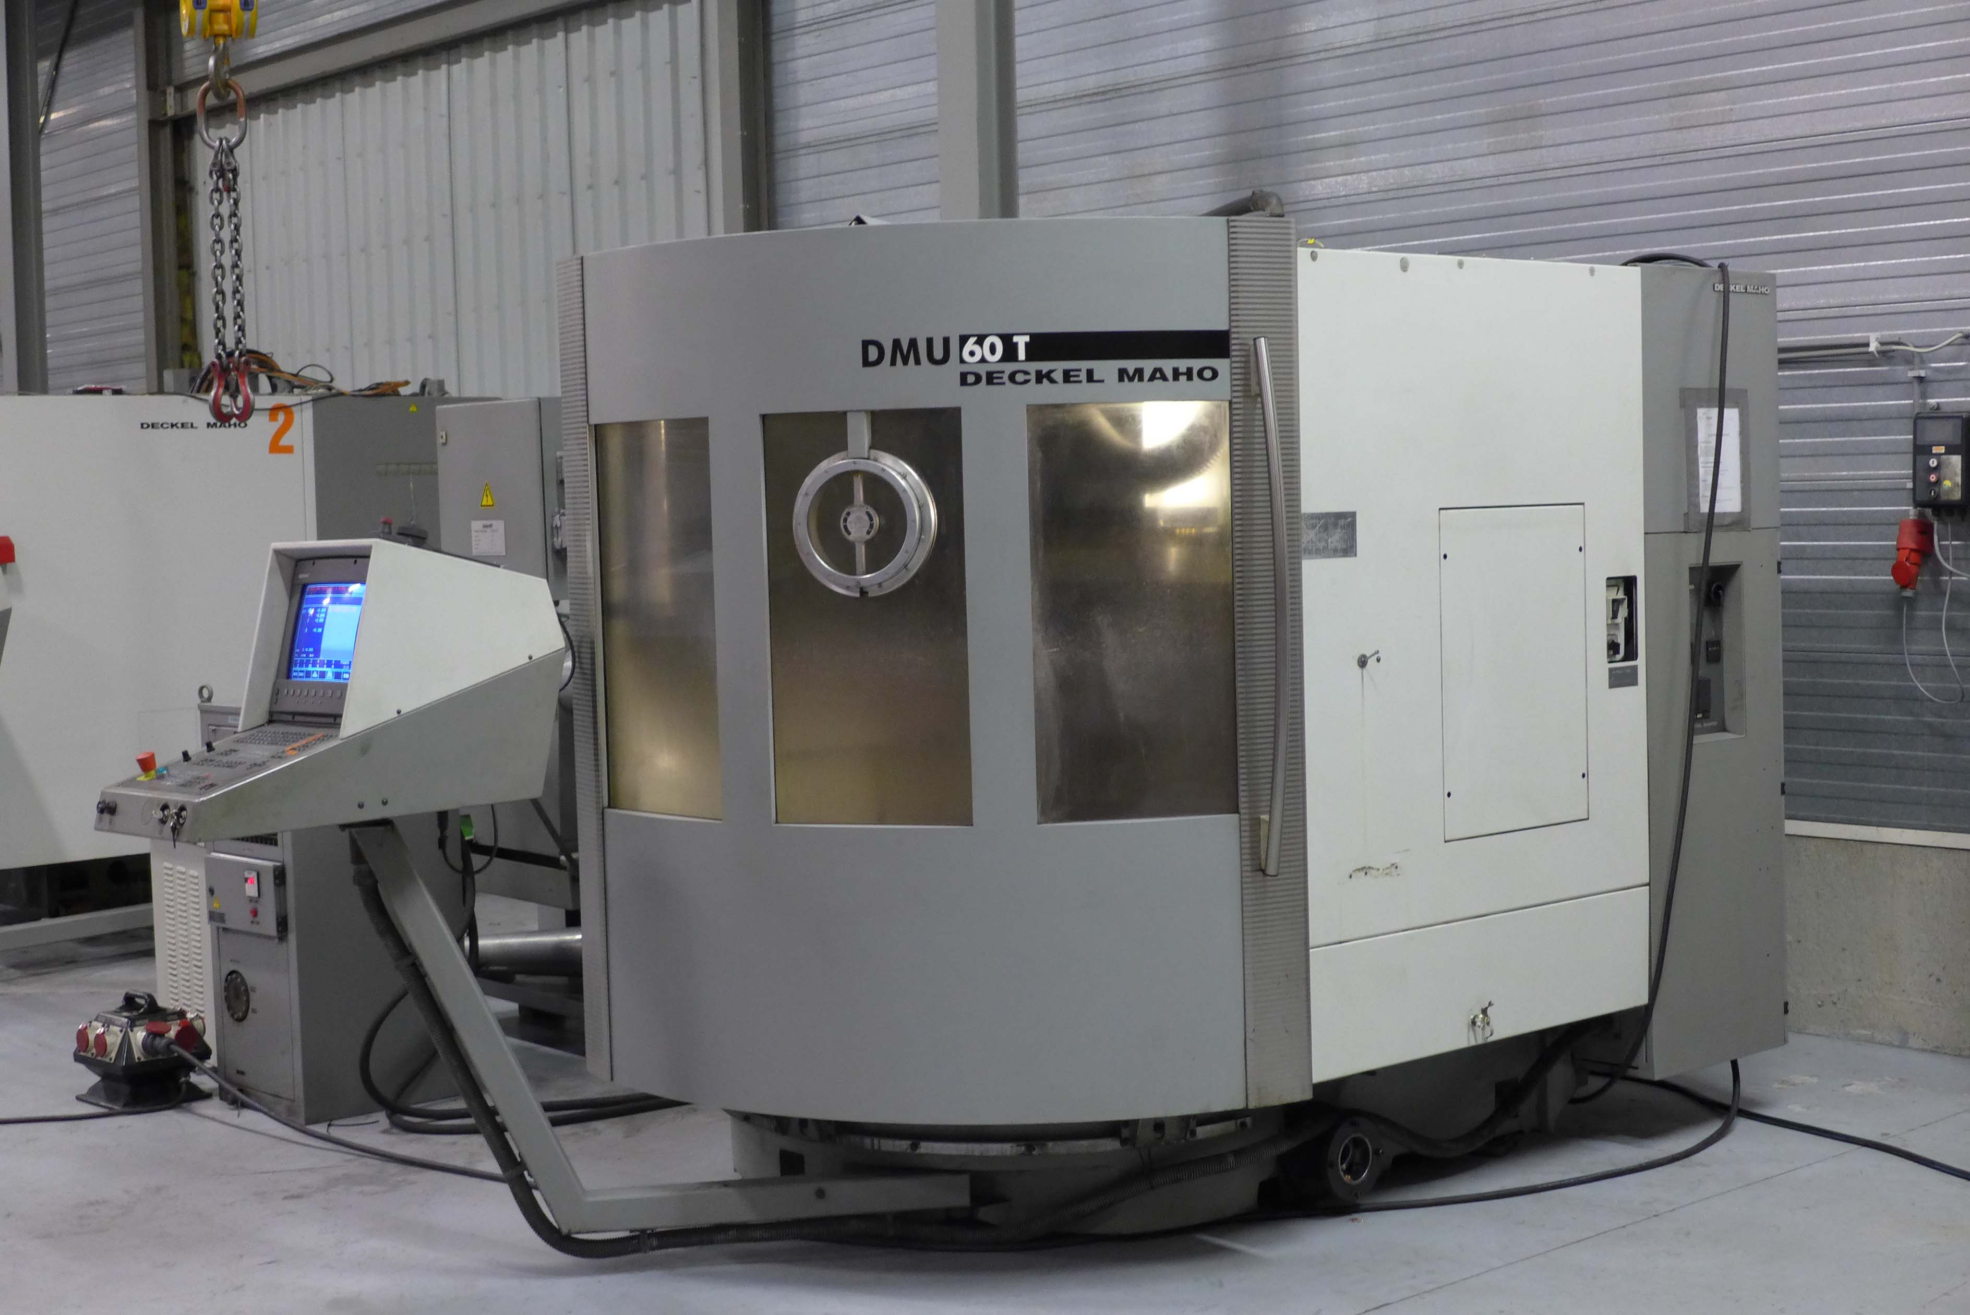

- ATC SK 40 & HSK 63
- HeidenHain TNC 426 M
- B Axis over CNC Panel
- Incl. IKZ & Chip conveyor

- Dimensions
- Length : 3.000
- Width : 3.500
- Height : 2.500
- Weight : 6.800

Please Note: The above information has been obtained to the best of our ability and belief from, and from the manufacturers where possible. It is given in good faith, but its accuracy can not be guaranteed. Accordingly, it will not form a representation or constitute contractual terms. We advise you to check any vital details!

